

Initial Client Prospectus

Example Business Overview (“EBO”)
St. Louis, Missouri

Table of Contents

Table of Contents 2
Executive Summary 3
Business Overview 5
Financial Summary 6
Customers 8
Employees 9

Executive Summary

Business Overview
EBO is based in St. Louis, Missouri, with offices in Columbia, Missouri and Chicago, Illinois. The company services 244 clients and 38K units, with 63 employees. This organization has a sizable maintenance business, representing over a third of total revenue. EBO is owned primarily by Bob and Jane, who each control 47.5% of the company. Their CFO, Bobbie, owns the remaining 5%, and manages client accounting. The company earned $8.9M in Pro Forma Dec’24 revenue and $2.0M (27% margin) in Pro Forma Dec’24 EBITDA.

Key Statistics
$20M - $26M  Asking Price Range | $8.9M  PF Dec’24 Revenue | $2.0M  PF Dec’24 EBITDA | 10.0x – 13.0x  EBITDA Multiple Range

Metric | Value | Notes | Valuation Impact
Year Founded | 1984 |  | Well-established business
Client Count | 244 |  | Platform-sized client base
Employee Count | 63 | Includes 24 employees that are pass-through payroll | Includes team leads which reduces post-closing risk
Pro Forma Dec’24 Revenue | $8.9M | Includes $800K of BSI income
Pro Forma Dec’24 EBITDA | $2.0M |  | Businesses in this range trade for 10.0x – 13.0x EBITDA
Y/Y Revenue Growth Rate | 28% | Supported by hiring four full-time employees | Proven growth engine increases future earnings expectations
5-Year Client Retention Rate | 95% | 5% above industry average | Decreases likelihood of client turnover post-close
Top 25 Client Concentration (% of EBITDA) | 18% | 15% above industry average | Significantly above-market, offer will likely include retention contingencies
5-Year Employee Retention Rate | 92% | 12% above industry average | Increases buyer confidence in post-closing employee retention
Payroll % of Revenue | 54% | 6% below industry average | Indicates operational efficiencies
Legend
Positively impacts valuation | Negatively impacts valuation

Valuation & Structure Rationale
In the association management industry, EBO’s valuation would trade between 10.0x – 13.0x based on the company’s $2M of PF Dec’24 EBITDA. EBO’s track record of client growth, client retention, employee retention, and staffing efficiency puts the company on the higher end of the valuation spectrum, implying a valuation of approximately $26M (13.0x multiple).
In terms of deal structure, EBO’s significant customer concentration will likely lead to an offer with contingent payments based on retaining specific clients for a period of time (likely 1 – 2 years) post close. Since both Bob and Jane would like to retire and currently work full-time as the CEO and CFO, buyers will likely request that they remain active for 6 – 18 months post-close as they buyer identifies, hires, and trains replacement executives to manage operations.

Recommended Offer Structure
Deal Term | Details
Asking Price | $26M
Valuation Multiple | 13.0x
Cash at Close | $21M (80% of valuation)
Seller Note | $5M, 18-month term, quarterly payments, 9.0% interest (20% of valuation)
Seller Note Contingencies | $1M reduction in seller note if Clients X, Y, or Z terminate service
Earnout (if applicable) | None
Seller Stay-On Agreement | One-year, full-time, $150K compensation
Employment Agreements | [Note key employees with signed employment agreements]
Working Capital | [To be negotiated — describe target or peg mechanism]
Asset vs. Stock Sale | Asset sale
Target Close Date | 07/31/25

Reason for Sale
The two majority owners, Bob and Jane (47.5% each), would like to retire and transition out of the company after a year of transition support. Bobbie (5% ownership) would like to stay on and continue supporting the business. She is comfortable selling her minority interest in the company.

Business Overview

EBO Description
EBO was founded in 1984 by Jane and Bob and has grown to become one of the leading HOA and condominium management firms in the St. Louis metro area. The Company provides full-service association management to 244 communities across Missouri, offering full-service management along with maintenance services.

Services Offered

Core Association Management Services
- Full-service HOA & condominium association management
- Board governance support and meeting facilitation
- Financial management: budgeting, accounts payable/receivable, reserve fund analysis
- Vendor management and contractor coordination
- Homeowner communications and portal management

Ancillary / Add-On Services
- In-house maintenance and repair coordination
- Transfer fee processing and resale document management
- Insurance certificate management
- Violation enforcement and compliance tracking

Service Area & Geography
Primary market: St. Louis Metro Area
Office location(s): 123 Blinded Office Blvd.
Remote / hybrid: Fully in-office

Software & Technology Stack
Client accounting: Vantaca
Corporate accounting: QuickBooks
Transfer & resales: CondoCerts
Payroll: Innovia
Client banking: First Citizens
Homeowner portal: Vantaca
CRM / Sales: N/A

Ownership Structure
Legal entity: LLC
State of formation: Missouri
Owner Name | Ownership % | Role | Post-Close Role
Bob | 47.5% | CEO | Retiring
Jane | 47.5% | CFO | Retiring
Bobbie | 5.0% | Head of Client Accounting | Head of Client Accounting

Financial Summary
Note: All figures in USD thousands unless noted. Financials are as provided by Seller and have not been independently audited.

Summary Income Statement
($000s) | 2021A | 2022A | 2023A | 2024A | TTM
Total Revenue | [$XXX] | [$XXX] | [$XXX] | [$XXX] | [$XXX]
Management Fees | [$XXX] | [$XXX] | [$XXX] | [$XXX] | [$XXX]
Transfer Fees | [$XXX] | [$XXX] | [$XXX] | [$XXX] | [$XXX]
Ancillary / Other | [$XXX] | [$XXX] | [$XXX] | [$XXX] | [$XXX]
Gross Profit | [$XXX] | [$XXX] | [$XXX] | [$XXX] | [$XXX]
GP Margin | [XX%] | [XX%] | [XX%] | [XX%] | [XX%]
Operating Expenses | [$XXX] | [$XXX] | [$XXX] | [$XXX] | [$XXX]
EBITDA | [$XXX] | [$XXX] | [$XXX] | [$XXX] | [$XXX]
EBITDA Margin | [XX%] | [XX%] | [XX%] | [XX%] | [XX%]
Seller Add-Backs | [$XXX] | [$XXX] | [$XXX] | [$XXX] | [$XXX]
Adjusted SDE | [$XXX] | [$XXX] | [$XXX] | [$XXX] | [$XXX]
SDE Margin | [XX%] | [XX%] | [XX%] | [XX%] | [XX%]

[ Commentary: describe 2–3 key financial trends — revenue trajectory, margin improvement, any one-time items. ]

EBITDA to SDE Bridge (Add-Back Schedule)
Add-Back Item | TTM Amount ($000s) | Rationale
Owner compensation above market replacement | [$XXX] | [Description]
Personal vehicle / auto expense | [$XXX] | [Description]
Owner health insurance & benefits | [$XXX] | [Description]
One-time / non-recurring expenses | [$XXX] | [Description]
Depreciation & amortization | [$XXX] | [Description]
Interest expense | [$XXX] | [Description]
Other personal expenses run through business | [$XXX] | [Description]
Total Add-Backs | [$XXX]

[ Commentary: explain the most significant add-backs. Note any owner expenses that required judgment or documentation. ]

Revenue Mix
Revenue Stream | TTM ($000s) | % of Total | Notes
Management Fees | [$XXX] | [XX%] | [Brief note]
Transfer Fees | [$XXX] | [XX%] | [Brief note]
Ancillary / Addendum Fees | [$XXX] | [XX%] | [Brief note]
Earnings Credits / Bank Income | [$XXX] | [XX%] | [Brief note]
Maintenance / Other | [$XXX] | [XX%] | [Brief note]
Total | [$XXX] | [100%]

[ Commentary: describe what drives each revenue stream. Note any streams that are recurring/contractual vs. transactional. ]

Revenue Trend Commentary
[ Describe the multi-year revenue trajectory in 2–4 sentences. Note CAGRs if meaningful. Explain any dips or spikes. ]
[Company Name] has grown revenue from $[X]K in [Year] to $[X]K in [Year], representing a [X]% compound annual growth rate. Growth has been driven primarily by [new client wins / price increases / geographic expansion]. [Note any year-over-year anomalies and their explanations.]

Customers

Customer Concentration
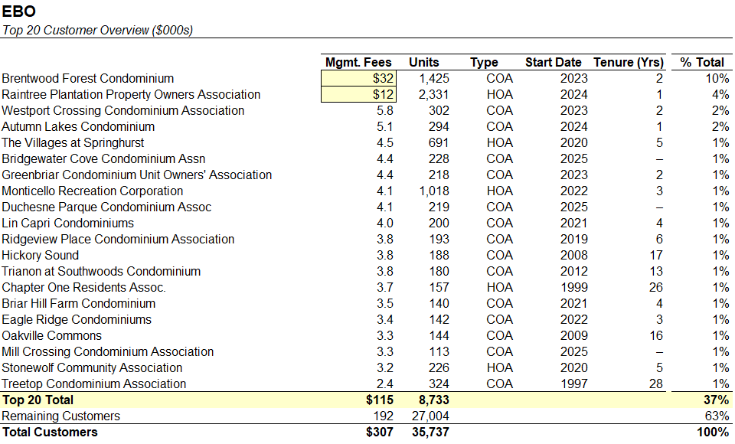
EBO’s largest customer is Brentwood Forest Condominiums, the largest condo complex in the state of Missouri. Brentwood has four dedicated onsite management personnel, three dedicated maintenance people, and is additionally in the midst of a significant capital improvement project being managed by EBO. Additionally, due to its size Brentwood averages ~$5M of deposits in bank accounts, which contributed meaningfully to earnings credit revenue. Given these diverse revenue streams, we estimate that Brentwood makes up 15-20% of overall earnings.
The customer relationship with Brentwood is strong, and Brentwood preemptively reached out to renew the contract and negotiations are ongoing. However, Brentwood is also going through a board election within the next month.

Client Retention Analysis

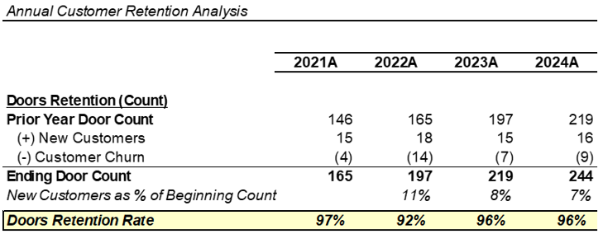

Employees

Employee Overview
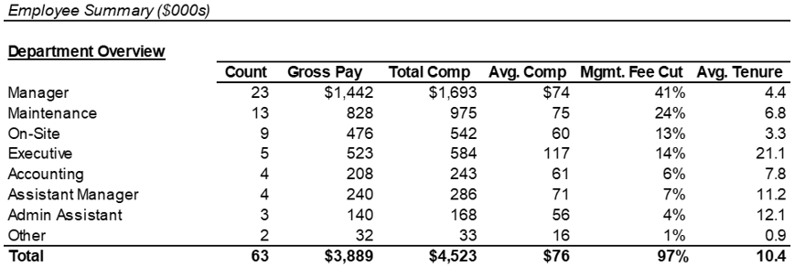

EBO operates with a CAM cut and mgmt. fee cut in-line with industry expectations. The company noted that all but one manager currently has capacity to take additional accounts, and no additional managers are needed for the foreseeable future.

Organizational Structure
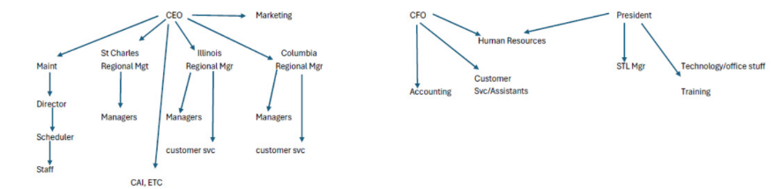

The company has a well-established bench of leadership, with regional managers reporting to the CEO (Bob).

Employee Retention Analysis
Metric | 2021A | 2022A | 2023A | 2024A | TTM
Employees (Beg. of Year) | [--] | [--] | [--] | [--] | [--]
(+) New Hires | [--] | [--] | [--] | [--] | [--]
(-) Voluntary Departures | [--] | [--] | [--] | [--] | [--]
(-) Involuntary Separations | [--] | [--] | [--] | [--] | [--]
Employees (End of Year) | [--] | [--] | [--] | [--] | [--]
Employee Retention Rate | [--] | [--] | [--] | [--] | [--]

